Data Science in Python Project Report
Analyzing crop yields in India

Submitted to: Ms. Anjali Luthra
Submitted by:
Name- Samadrita Mukherjee
Course- Bachelors of Computer Applications
Year- 2nd (2025-26)
College- Vivekananda Institute of Professional Studies - Technical Campus
Email ID- mukherjeesamadrita05@gmail.com

TABLE OF CONTENTS
- Introduction
- Objectives
- Literature review
- Project flow
- Tools & Technologies
- Software
- Python libraries
- Implementation
- crop project.py
- dashboard.py
- Results & discussions
- Dashboard overview
- Conclusion
- Limitations
- Future scope
- Bibliography and references

INTRODUCTION
Agriculture is the backbone of India’s economy, providing livelihood to a large section of the population and ensuring food security for the nation. With changing climatic conditions, varying rainfall patterns, and increased use of fertilizers and pesticides, understanding how these factors affect crop yield has become increasingly important.
This project focuses on analyzing crop yield data from different states of India to study how factors like rainfall, fertilizer, and pesticide usage influence agricultural productivity. Using Python for data analysis and visualization, the project aims to identify yield trends, compare state-wise performance, and explore the relationships between various agricultural inputs and outputs.

OBJECTIVES
- To analyze crop yield patterns across different Indian states from 1997 to 2020.
- To study the relationship between rainfall, fertilizer, pesticide usage, and crop yield.
- To identify the most productive crops and states based on yield performance.
- To observe seasonal variations in agricultural production.
- To generate useful insights that can help understand factors influencing agricultural productivity.

LITERATURE REVIEW
Previous studies have shown that data analytics can play a major role in improving agricultural productivity. Researchers have analyzed crop yield data to understand how factors like rainfall, soil quality, and fertilizer usage impact production.
With the rise of open datasets and tools such as Python, it has become easier to visualize and interpret large agricultural data. This project builds on these approaches to analyze crop yield trends in India and study the influence of rainfall, fertilizer, and pesticide use on overall productivity.
PROJECT FLOW

TOOLS AND TECHNOLOGIES
The project utilizes various software tools and Python libraries for data analysis, visualization, and reporting. Each tool plays a specific role in different stages of the analysis process.
1. Software Tools
- Python 3.x – The primary programming language used for data analysis and visualization.
- Microsoft Excel / CSV Files – Used for dataset storage and basic data inspection.
- Dataset from Kaggle – Agricultural Crop Yield in Indian States Dataset (1997 to 2020)

2. Python Libraries
- Pandas – For data loading, cleaning, manipulation, and summarization.
- Matplotlib – For creating basic plots such as line charts, bar charts, and scatter plots.
- Seaborn – For enhanced, aesthetic visualizations like heatmaps and statistical graphs.
- Streamlit – for building an interactive dashboard and displaying visual insights

IMPLEMENTATION
Crop project.py-
import pandas as pd
import matplotlib.pyplot as plt
import seaborn as sns

# STEP 1: IMPORT & LOAD DATA

print("Step 1: Loading Data...")

# Load the dataset
df = pd.read_csv('crop_yield.csv')

# Basic data check
print("Dataset Shape:", df.shape)
print("\nColumn Names:")
print(df.columns.tolist())
print("\nFirst 5 rows:")
print(df.head())
print("\nDataset Info:")
print(df.info())
print("\nNull values:")
print(df.isnull().sum())

# STEP 2: DATA CLEANING / PREPARATION
print("\nStep 2: Data Cleaning...")

# Check data types
print("Current data types:")
print(df.dtypes)

# Convert Year to integer if needed
if 'Crop_Year' in df.columns:
df['Year'] = df['Crop_Year'].astype(int)
elif 'Year' in df.columns:
df['Year'] = df['Year'].astype(int)

# Convert categorical columns
categorical_cols = ['State', 'Crop', 'Season']
for col in categorical_cols:
if col in df.columns:
df[col] = df[col].astype('category')

# Set pandas groupby behavior to avoid warnings
pd.set_option('future.no_silent_downcasting', True)

# Handle outliers - remove rows with zero production but positive area
if 'Area' in df.columns and 'Production' in df.columns:
outliers = df[(df['Area'] > 0) & (df['Production'] == 0)]
print(f"Found {len(outliers)} outliers (Area > 0 but Production = 0)")
df = df[~((df['Area'] > 0) & (df['Production'] == 0))]

print(f"Clean dataset shape: {df.shape}")

# STEP 3: 5 ESSENTIAL CHARTS
print("\nStep 3: Creating 5 Essential Charts...")

# CHART 1: Line Plot - Yield Trend Over Years
print("\nChart 1: Yield Trend Over Years (Line Plot)")

if 'Year' in df.columns and 'Yield' in df.columns:
yearly_yield = df.groupby('Year', observed=True)['Yield'].mean()

plt.figure(figsize=(12, 6))
plt.plot(yearly_yield.index, yearly_yield.values, marker='o', linewidth=2, markersize=6, color='green')
plt.title('Average Crop Yield Trend Over Years (1997-2020)', fontsize=14)
plt.xlabel('Year')
plt.ylabel('Average Yield (tons per hectare)')
plt.grid(True, alpha=0.3)
plt.tight_layout()
plt.show()

# CHART 2: Bar Chart - Top 10 States by Yield
print("\nChart 2: Top States by Yield (Bar Chart)")

if 'State' in df.columns and 'Yield' in df.columns:
top_states_yield = df.groupby('State', observed=True)['Yield'].mean().sort_values(ascending=False).head(10)

plt.figure(figsize=(14, 8))
bars = plt.bar(range(len(top_states_yield)), top_states_yield.values, color='skyblue', edgecolor='navy')
plt.title('Top 10 States by Average Yield', fontsize=14)
plt.xlabel('States')
plt.ylabel('Average Yield (tons per hectare)')
plt.xticks(range(len(top_states_yield)), top_states_yield.index, rotation=45)

# Add value labels on bars
for i, bar in enumerate(bars):
height = bar.get_height()
plt.text(bar.get_x() + bar.get_width()/2., height + 0.01,
f'{height:.2f}', ha='center', va='bottom')

plt.tight_layout()
plt.show()

# CHART 3: Pie Chart - Seasonal Distribution
print("\nChart 3: Seasonal Distribution (Pie Chart)")

if 'Season' in df.columns and 'Yield' in df.columns:
seasonal_yield = df.groupby('Season', observed=True)['Yield'].mean()

plt.figure(figsize=(14, 8))
colors = ['gold', 'lightcoral', 'lightskyblue', 'lightgreen', 'orange']
wedges, texts = plt.pie(seasonal_yield.values,
startangle=90,
colors=colors[:len(seasonal_yield)])

plt.title('Average Yield Distribution by Season', fontsize=16, pad=20)
plt.axis('equal')
total = sum(seasonal_yield.values)
legend_labels = []
for season, value in seasonal_yield.items():
percentage = (value/total) * 100
legend_labels.append(f'{season}: {percentage:.1f}%')

plt.legend(wedges, legend_labels,
title="Seasons & Percentages",
loc="center left",
bbox_to_anchor=(1, 0, 0.5, 1),
fontsize=12)

plt.tight_layout()
plt.show()

# CHART 4: Scatter Plot - Rainfall vs Yield
print("\nChart 4: Rainfall vs Yield Relationship (Scatter Plot)")

if 'Annual_Rainfall' in df.columns and 'Yield' in df.columns:
plt.figure(figsize=(12, 8))
plt.scatter(df['Annual_Rainfall'], df['Yield'], alpha=0.6, color='blue', s=30)
plt.title('Annual Rainfall vs Crop Yield', fontsize=14)
plt.xlabel('Annual Rainfall (mm)')
plt.ylabel('Crop Yield (tons per hectare)')
plt.grid(True, alpha=0.3)
plt.tight_layout()
plt.show()

# Calculate and show correlation
correlation = df['Annual_Rainfall'].corr(df['Yield'])
print(f"Correlation between Annual Rainfall and Yield: {correlation:.3f}")

# CHART 5: Heatmap - Correlation Between Variables
print("\nChart 5: Correlation Heatmap")

# Select only numeric columns for correlation
numeric_cols = df.select_dtypes(include=['int64', 'float64'])

if len(numeric_cols.columns) > 1:
plt.figure(figsize=(10, 8))
correlation_matrix = numeric_cols.corr()

# Create heatmap
sns.heatmap(correlation_matrix,
annot=True, # Show correlation numbers
cmap='RdYlBu_r', # Color scheme
center=0, # Center at 0
square=True, # Make squares
fmt='.2f') # Show 2 decimal places

plt.title('Correlation Heatmap - Relationships Between Variables', fontsize=14)
plt.tight_layout()
plt.show()

# STEP 4: SUMMARY STATISTICS

print("\nStep 4: Summary Statistics...")

print("Dataset Summary:")
print(df.describe())

if 'State' in df.columns:
print(f"\nNumber of States/UTs: {df['State'].nunique()}")

if 'Crop' in df.columns:
print(f"Number of Different Crops: {df['Crop'].nunique()}")

if 'Year' in df.columns:
print(f"Years covered: {df['Year'].min()} to {df['Year'].max()}")

print(f"Total records: {len(df)}")

# Key insights
print("\n=== KEY INSIGHTS ===")
if 'State' in df.columns and 'Yield' in df.columns:
best_state = df.groupby('State', observed=True)['Yield'].mean().idxmax()
best_yield = df.groupby('State', observed=True)['Yield'].mean().max()
print(f"Best performing state: {best_state} (Yield: {best_yield:.2f})")

if 'Season' in df.columns and 'Production' in df.columns:
best_season = df.groupby('Season', observed=True)['Production'].sum().idxmax()
print(f"Most productive season: {best_season}")

if 'Annual_Rainfall' in df.columns and 'Yield' in df.columns:
rainfall_corr = df['Annual_Rainfall'].corr(df['Yield'])
if rainfall_corr > 0.3:
print("✓ Rainfall has a positive impact on crop yield")
elif rainfall_corr < -0.3:
print("✓ Too much rainfall may reduce crop yield")
else:
print("✓ Rainfall has minimal impact on crop yield")

print("\n=== ANALYSIS COMPLETE ===")
print("5 essential charts created successfully!")
OUTPUT-
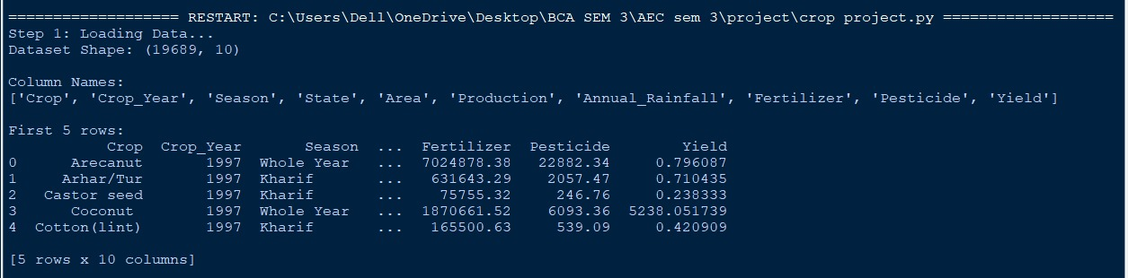
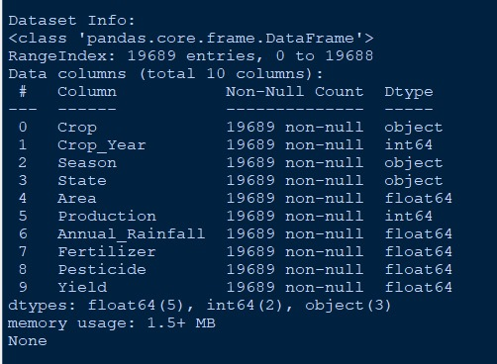
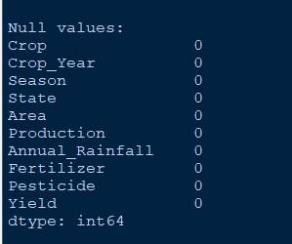
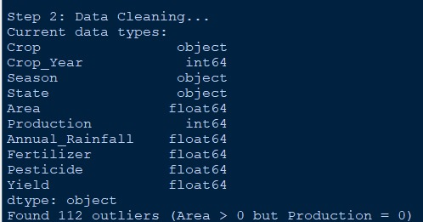

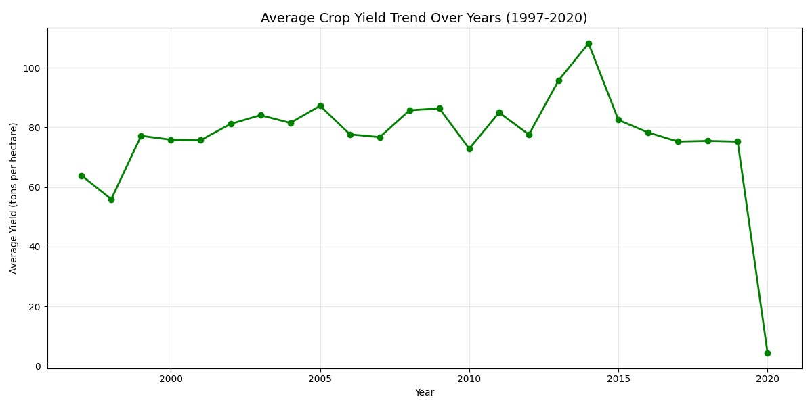
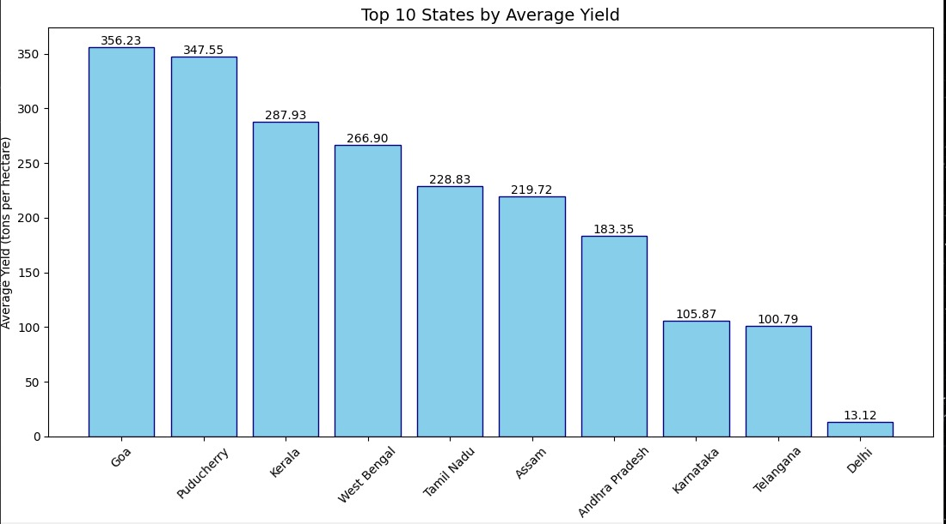
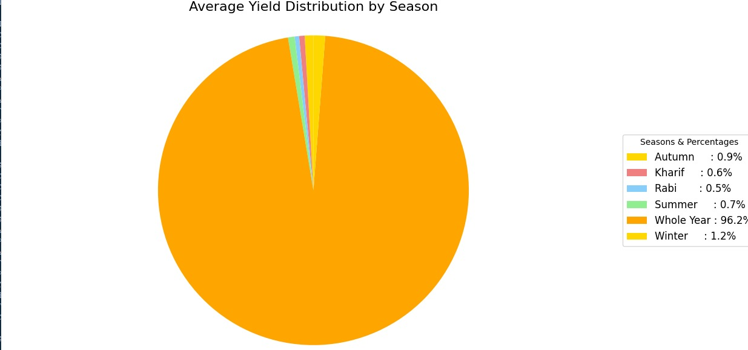
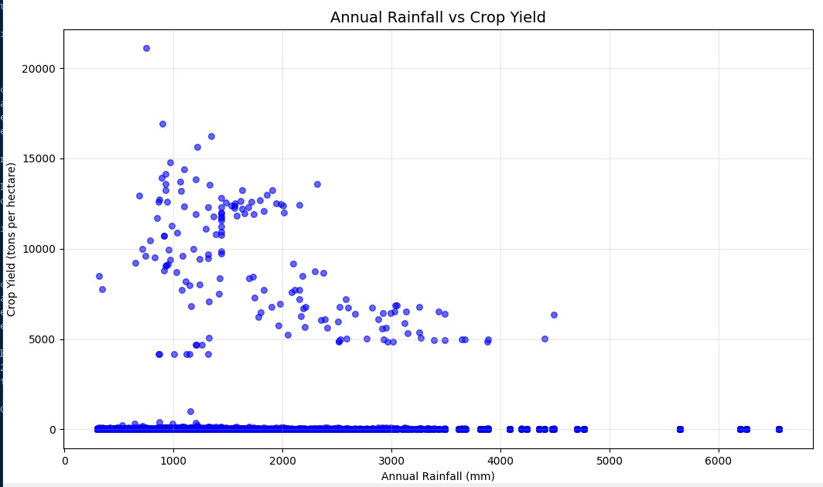
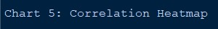
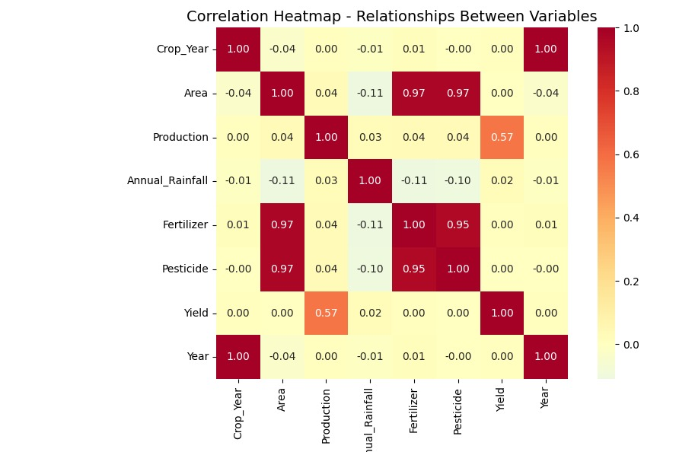
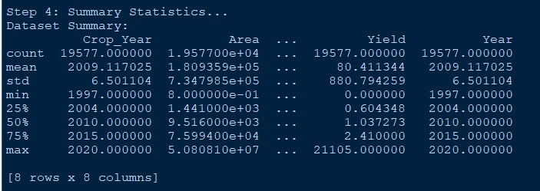
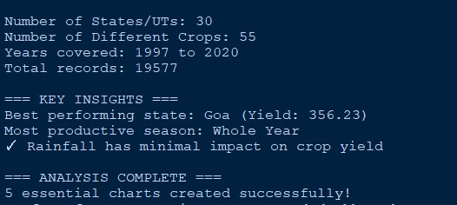

dashboard.py-
import streamlit as st
import pandas as pd
import matplotlib.pyplot as plt
import seaborn as sns

# Page configuration
st.set_page_config(page_title="Crop Yield Dashboard", page_icon="🌾", layout="wide")

# Title
st.title("🌾 Crop Yield Analysis Dashboard")
st.markdown("### Indian States Dataset (1997-2020)")

# Load data
@st.cache_data
def load_data():
df = pd.read_csv('crop_yield.csv')

# Convert Year
if 'Crop_Year' in df.columns:
df['Year'] = df['Crop_Year'].astype(int)

# Clean outliers
if 'Area' in df.columns and 'Production' in df.columns:
df = df[~((df['Area'] > 0) & (df['Production'] == 0))]

return df

df = load_data()

# Sidebar filters
st.sidebar.header("🔍 Filter Options")

# State filter
states = ['All States'] + sorted(df['State'].unique().tolist())
selected_state = st.sidebar.selectbox("Select State", states)

# Crop filter
crops = ['All Crops'] + sorted(df['Crop'].unique().tolist())
selected_crop = st.sidebar.selectbox("Select Crop", crops)

# Season filter
seasons = ['All Seasons'] + sorted(df['Season'].unique().tolist())
selected_season = st.sidebar.selectbox("Select Season", seasons)

# Year range filter
min_year = int(df['Year'].min())
max_year = int(df['Year'].max())
year_range = st.sidebar.slider("Select Year Range", min_year, max_year, (min_year, max_year))

# Apply filters
filtered_df = df.copy()

if selected_state != 'All States':
filtered_df = filtered_df[filtered_df['State'] == selected_state]

if selected_crop != 'All Crops':
filtered_df = filtered_df[filtered_df['Crop'] == selected_crop]

if selected_season != 'All Seasons':
filtered_df = filtered_df[filtered_df['Season'] == selected_season]

filtered_df = filtered_df[(filtered_df['Year'] >= year_range[0]) & (filtered_df['Year'] <= year_range[1])]

# Display summary statistics
st.subheader("📊 Summary Statistics")

col1, col2, col3, col4 = st.columns(4)

with col1:
st.metric("Total Records", len(filtered_df))

with col2:
avg_yield = filtered_df['Yield'].mean()
st.metric("Average Yield", f"{avg_yield:.2f}")

with col3:
total_production = filtered_df['Production'].sum()
st.metric("Total Production", f"{total_production:,.0f}")

with col4:
total_area = filtered_df['Area'].sum()
st.metric("Total Area", f"{total_area:,.0f}")

st.markdown("---")

# CHART 1: Line Plot - Yield Trend Over Years
st.subheader("📈 Chart 1: Yield Trend Over Years")

if len(filtered_df) > 0:
yearly_yield = filtered_df.groupby('Year')['Yield'].mean()

fig1, ax1 = plt.subplots(figsize=(12, 6))
ax1.plot(yearly_yield.index, yearly_yield.values, marker='o', linewidth=2, markersize=6, color='green')
ax1.set_title('Average Crop Yield Trend Over Years', fontsize=14)
ax1.set_xlabel('Year')
ax1.set_ylabel('Average Yield (tons per hectare)')
ax1.grid(True, alpha=0.3)
plt.tight_layout()
st.pyplot(fig1)
else:
st.warning("No data available for the selected filters.")

st.markdown("---")

# CHART 2: Bar Chart - Top 10 States by Yield
st.subheader("📊 Chart 2: Top 10 States by Average Yield")

if len(filtered_df) > 0 and selected_state == 'All States':
top_states_yield = filtered_df.groupby('State')['Yield'].mean().sort_values(ascending=False).head(10)

fig2, ax2 = plt.subplots(figsize=(12, 6))
bars = ax2.bar(range(len(top_states_yield)), top_states_yield.values, color='skyblue', edgecolor='navy')
ax2.set_title('Top 10 States by Average Yield', fontsize=14)
ax2.set_xlabel('States')
ax2.set_ylabel('Average Yield (tons per hectare)')
ax2.set_xticks(range(len(top_states_yield)))
ax2.set_xticklabels(top_states_yield.index, rotation=45, ha='right')

# Add value labels on bars
for i, bar in enumerate(bars):
height = bar.get_height()
ax2.text(bar.get_x() + bar.get_width()/2., height + 0.01,
f'{height:.2f}', ha='center', va='bottom')

plt.tight_layout()
st.pyplot(fig2)
elif selected_state != 'All States':
st.info("💡 Select 'All States' to view state comparison.")
else:
st.warning("No data available for the selected filters.")

st.markdown("---")

# CHART 3: Pie Chart - Seasonal Distribution
st.subheader("🥧 Chart 3: Seasonal Distribution")

if len(filtered_df) > 0:
seasonal_yield = filtered_df.groupby('Season')['Yield'].mean()

fig3, ax3 = plt.subplots(figsize=(10, 6))
colors = ['gold', 'lightcoral', 'lightskyblue', 'lightgreen', 'orange']

wedges, texts = ax3.pie(seasonal_yield.values,
startangle=90,
colors=colors[:len(seasonal_yield)])

ax3.set_title('Average Yield Distribution by Season', fontsize=14)
ax3.axis('equal')

# Create legend
total = sum(seasonal_yield.values)
legend_labels = []
for season, value in seasonal_yield.items():
percentage = (value/total) * 100
legend_labels.append(f'{season}: {percentage:.1f}%')

ax3.legend(wedges, legend_labels,
title="Seasons & Percentages",
loc="center left",
bbox_to_anchor=(1, 0, 0.5, 1),
fontsize=10)

plt.tight_layout()
st.pyplot(fig3)
else:
st.warning("No data available for the selected filters.")

st.markdown("---")

# CHART 4: Scatter Plot - Rainfall vs Yield
st.subheader("💧 Chart 4: Rainfall vs Yield Relationship")

if len(filtered_df) > 0:
fig4, ax4 = plt.subplots(figsize=(12, 6))
ax4.scatter(filtered_df['Annual_Rainfall'], filtered_df['Yield'], alpha=0.6, color='blue', s=30)
ax4.set_title('Annual Rainfall vs Crop Yield', fontsize=14)
ax4.set_xlabel('Annual Rainfall (mm)')
ax4.set_ylabel('Crop Yield (tons per hectare)')
ax4.grid(True, alpha=0.3)
plt.tight_layout()
st.pyplot(fig4)

# Calculate and show correlation
correlation = filtered_df['Annual_Rainfall'].corr(filtered_df['Yield'])
st.info(f"📊 Correlation between Annual Rainfall and Yield: **{correlation:.3f}**")
else:
st.warning("No data available for the selected filters.")

st.markdown("---")

# CHART 5: Heatmap - Correlation Between Variables
st.subheader("🔥 Chart 5: Correlation Heatmap")

if len(filtered_df) > 0:
numeric_cols = filtered_df.select_dtypes(include=['int64', 'float64'])

fig5, ax5 = plt.subplots(figsize=(10, 8))
correlation_matrix = numeric_cols.corr()

sns.heatmap(correlation_matrix,
annot=True,
cmap='RdYlBu_r',
center=0,
square=True,
fmt='.2f',
ax=ax5)

ax5.set_title('Correlation Heatmap - Relationships Between Variables', fontsize=14)
plt.tight_layout()
st.pyplot(fig5)
else:
st.warning("No data available for the selected filters.")

st.markdown("---")

# Key Insights Section
st.subheader("💡 Key Insights")

if len(filtered_df) > 0:
col1, col2 = st.columns(2)

with col1:
st.write("**Best Performing State:**")
best_state = filtered_df.groupby('State')['Yield'].mean().idxmax()
best_yield = filtered_df.groupby('State')['Yield'].mean().max()
st.success(f"🏆 {best_state} (Yield: {best_yield:.2f})")

st.write("**Most Productive Season:**")
best_season = filtered_df.groupby('Season')['Production'].sum().idxmax()
st.success(f"🌸 {best_season}")

with col2:
st.write("**Top Crop by Yield:**")
best_crop = filtered_df.groupby('Crop')['Yield'].mean().idxmax()
best_crop_yield = filtered_df.groupby('Crop')['Yield'].mean().max()
st.success(f"🌾 {best_crop} (Yield: {best_crop_yield:.2f})")

st.write("**Rainfall Impact:**")
rainfall_corr = filtered_df['Annual_Rainfall'].corr(filtered_df['Yield'])
if rainfall_corr > 0.3:
st.success("✓ Rainfall has a positive impact on crop yield")
elif rainfall_corr < -0.3:
st.warning("⚠ Too much rainfall may reduce crop yield")
else:
st.info("ℹ Rainfall has minimal impact on crop yield")
else:
st.warning("No data available for the selected filters.")

# Footer
st.markdown("---")
st.markdown("### 📚 About This Dashboard")
st.write("This interactive dashboard analyzes crop yield data from Indian states (1997-2020).")
st.write("Use the sidebar filters to explore different states, crops, seasons, and time periods.")

OUTPUT-
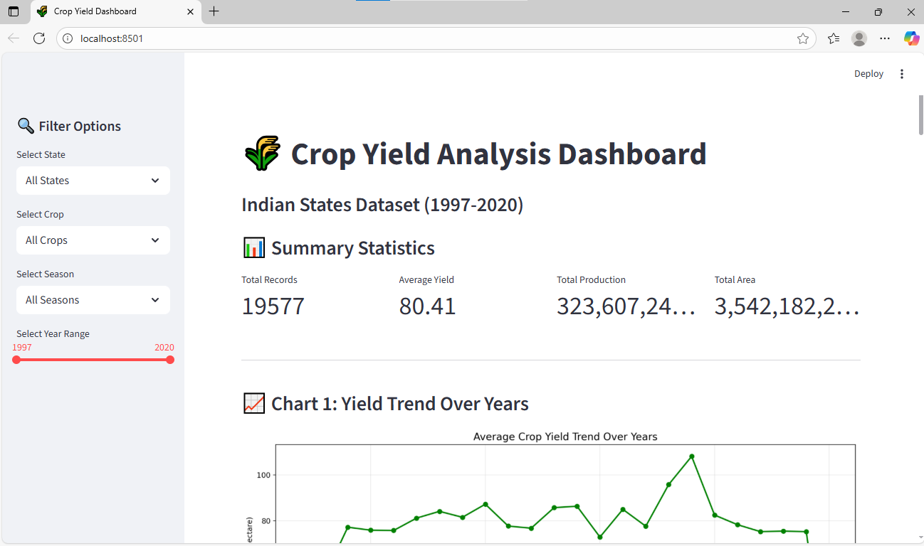
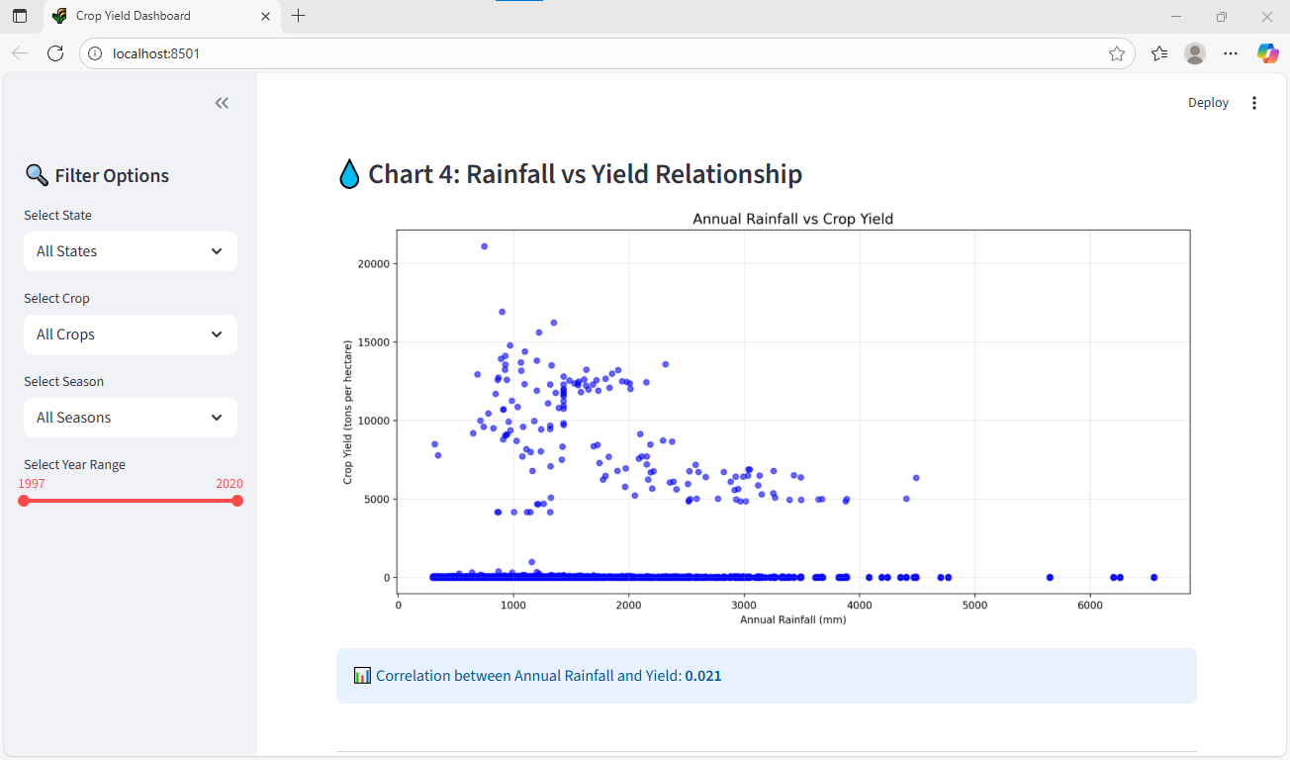
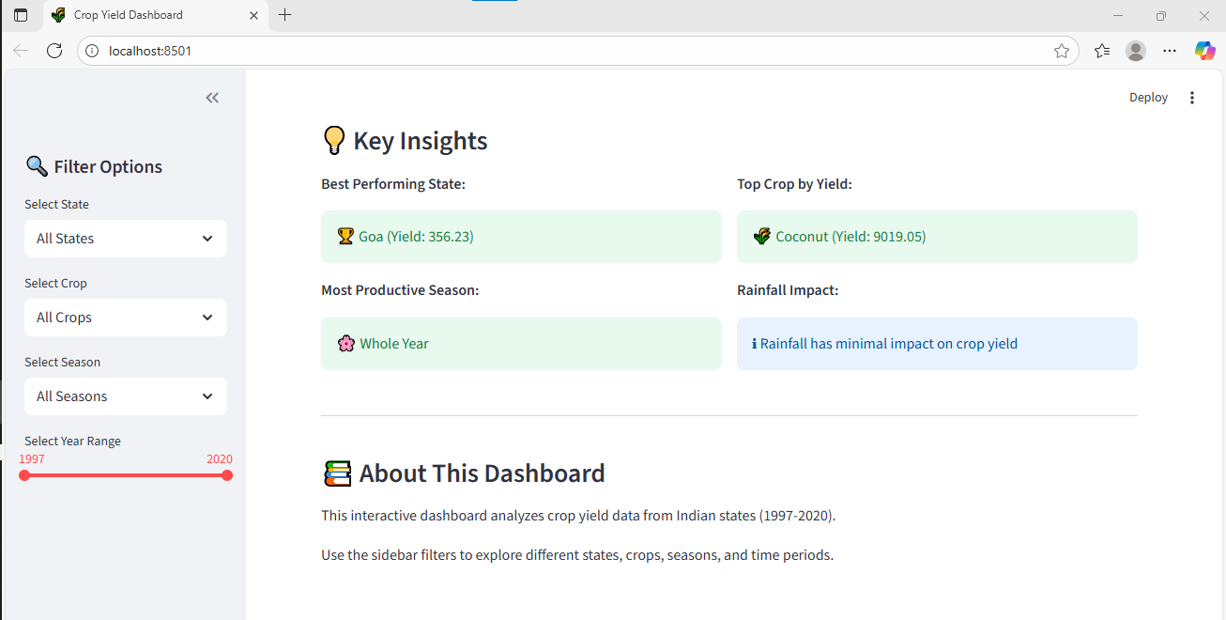

Sample state – DELHI
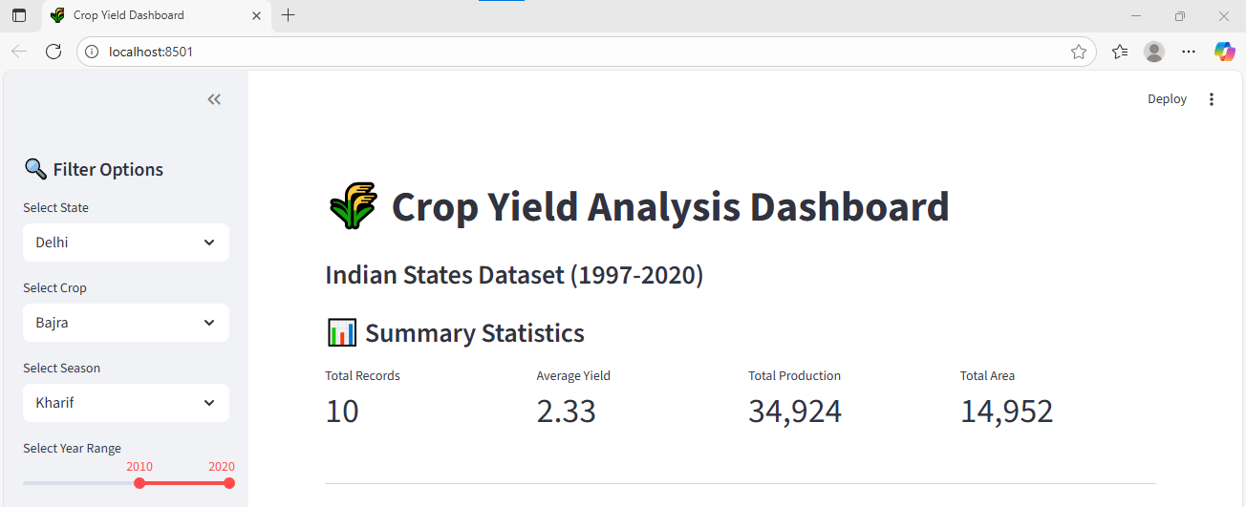
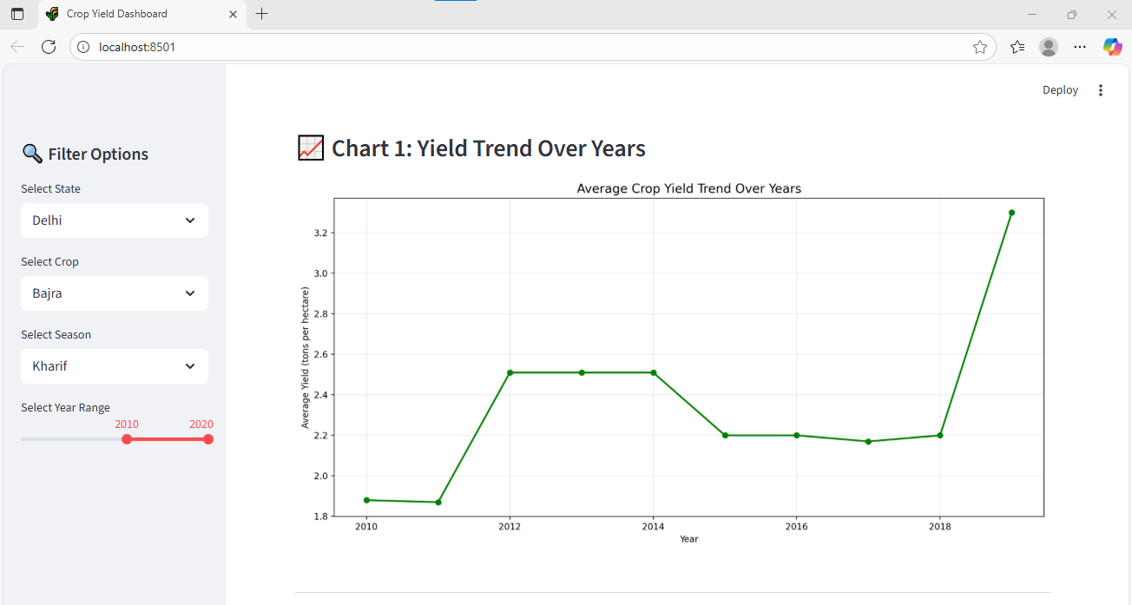
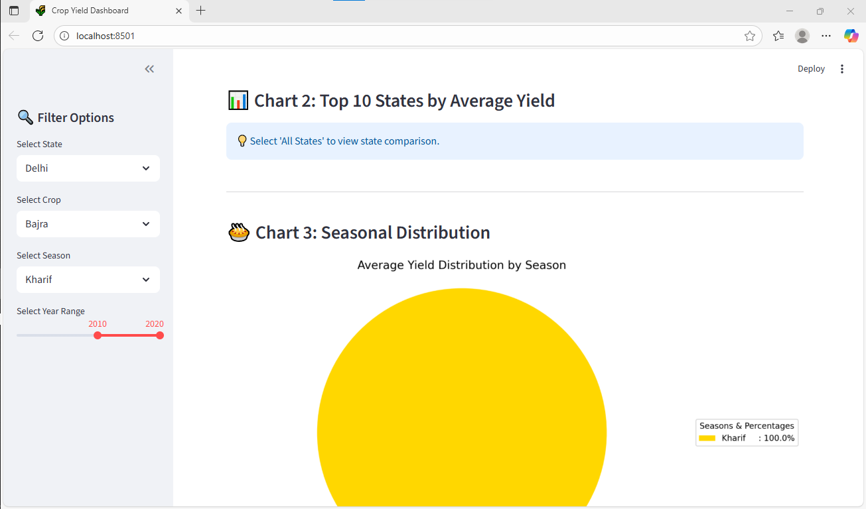
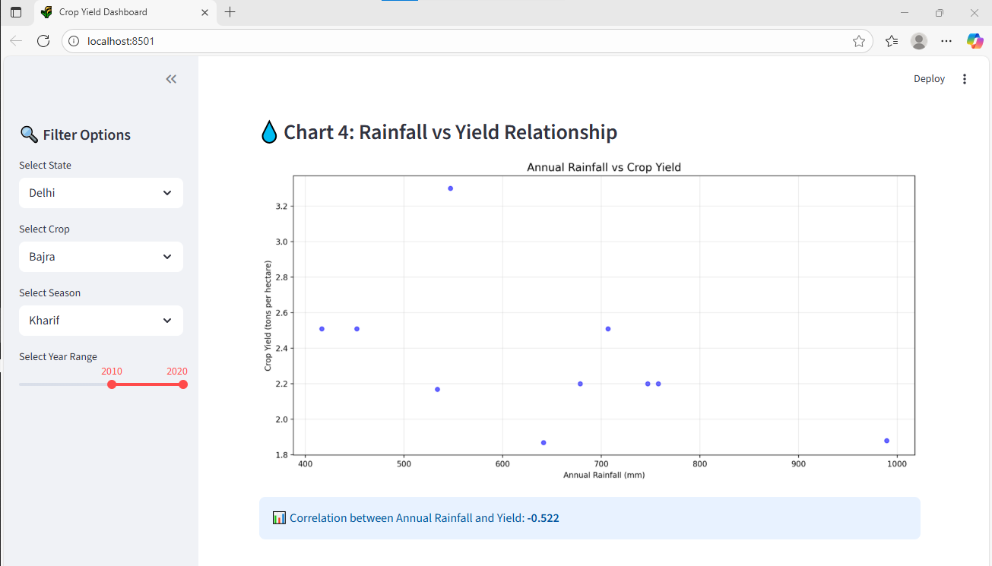
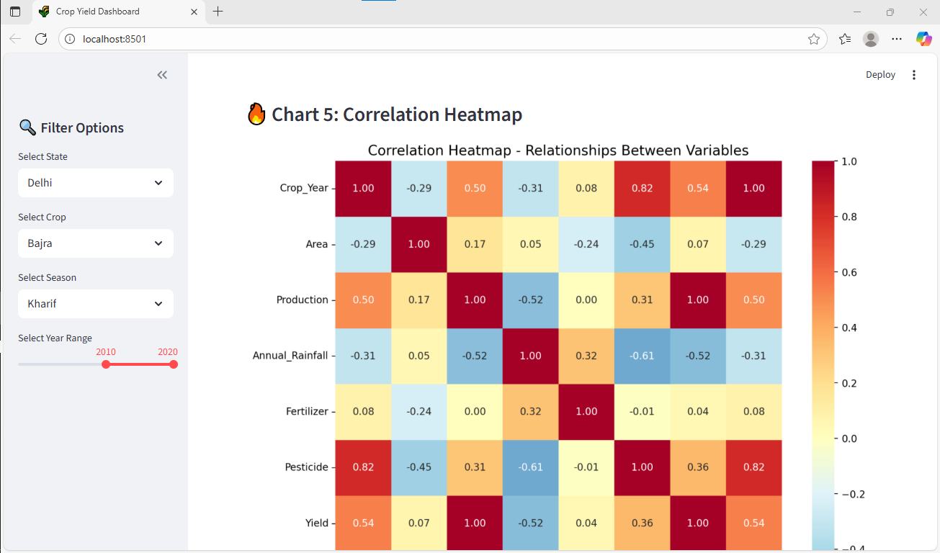
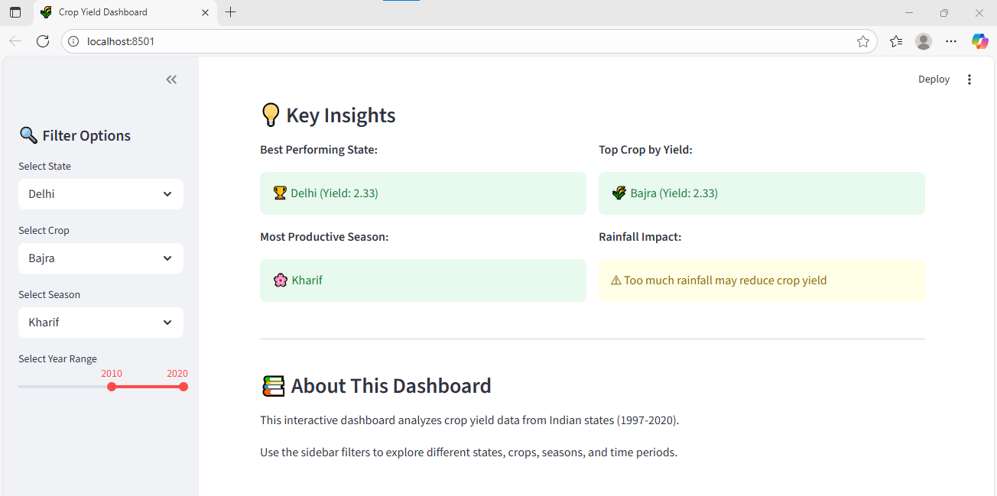

RESULTS & DISCUSSIONS
The analysis of the India Crop Yield dataset revealed useful patterns in agricultural production across states and years.
- Crop Trends: Rice, Wheat, and Maize were found to be the most widely grown crops.
- Regional Insights: Uttar Pradesh, Madhya Pradesh, and Maharashtra showed consistently high production levels.
- Seasonal Variation: Kharif crops generally had higher yields than Rabi crops.
- Yearly Trends: Crop production fluctuated over time, possibly due to rainfall and other climatic factors.
- Correlation: A positive link was observed between cultivated area and total production.
These findings show how data analysis can support better decision-making in agriculture by identifying key crops, regions, and growth trends.

DASHBOARD OVERVIEW

An interactive dashboard was developed using Streamlit to visualize and analyze crop yield data across Indian states. The dashboard allows users to explore trends dynamically through various filters such as State, Crop, Season, and Year Range.
It presents key visual insights through multiple charts:
- Line Chart: Displays average yield trends over the years.
- Bar Chart: Compares top states by average yield.
- Pie Chart: Shows seasonal yield distribution.
- Scatter Plot: Highlights the relationship between rainfall and yield.
- Heatmap: Illustrates correlations between numerical variables.
This dashboard makes the analysis more interactive and user-friendly, helping users understand agricultural patterns and the impact of various factors on crop yield in India.

CONCLUSION
This project provided a clear understanding of crop production trends across India using data analysis techniques in Python. By examining factors such as crop type, region, and season, valuable insights were gained into patterns that influence agricultural output.
The study highlights the potential of data-driven approaches to support farmers, researchers, and policymakers in making informed decisions for improving productivity and sustainability in Indian agriculture.

LIMITATIONS
- The dataset may not include the most recent years, limiting the accuracy of current trend analysis.
- Some states or crops may have incomplete or missing data, affecting overall comparisons.
- External factors such as weather, soil fertility, and market conditions were not considered.
- Visualizations are static and could be enhanced with interactive tools for deeper insights.

FUTURE SCOPE
- Incorporating recent datasets to analyze the latest agricultural trends and climate impacts.
- Including additional factors such as rainfall, fertilizer usage, and soil type to improve accuracy.
- Applying predictive models (like linear regression or time-series forecasting) to estimate future crop yields.
- Expanding the analysis to include state-wise comparisons and recommendations for crop optimization.

BIBLIOGRAPHY & REFERENCES
- Government of India, Ministry of Agriculture & Farmers Welfare – Agricultural Statistics at a Glance.
https://agricoop.nic.in/
- Kaggle Datasets – Crop Production and Yield Data (India, 1997–2020).
https://www.kaggle.com/
- Pandas Documentation – Data Analysis in Python.
https://pandas.pydata.org/docs/
- Matplotlib Documentation – Data Visualization with Python.
https://matplotlib.org/stable/contents.html
- Seaborn Documentation – Statistical Data Visualization.
https://seaborn.pydata.org/
- Streamlit Documentation – Building Interactive Dashboards.
https://docs.streamlit.io/
- Singh, R., & Sharma, V. (2020). An Analysis of Crop Yield Patterns in Indian Agriculture Using Machine Learning Techniques. International Journal of Agricultural Sciences, 12(4), 45–52.
- FAO (Food and Agriculture Organization of the United Nations). (2021). FAOSTAT – Crop Production Data.
https://www.fao.org/faostat/

